caTissue CTRP Integration Design

V 0.0.6

03/23/2011

Authors | Denis G. Krylov, Carlos E. Perez
Reviewers | Patrick McConnell, Srikalyan Swayampakula, Srikanth Adiga
Architecture Inception Team | N/A

DOCUMENT CHANGE HISTORY
Version Number | Date | Contributor | Description
0.0.1 | 08/17/2010 | Carlos Perez | Initial version
0.0.2 | 01/27/2011 | Carlos Perez | Update COPPA models
0.0.3 | 02/16/2011 | Carlos Perez | Updated based on comments by Patrick, Denis and Srikaylan
0.0.4 | 02/25/2011 | Carlos Perez | Updated mappings.
0.0.5 | 03/17/2011 | Denis Krylov | Major rewrite.
0.0.6 | 03/23/2011 | Denis Krylov | Addressed Srikanth’s comments.

Table of Contents
CTRP and 3
COPPA 3
Overview 3
Integration Design 3
Remote Entities 3
Affected Entities 3
Required Changes 3
Supporting Libraries 3
User Interface 3
Create Screens 3
Edit Screens 3
Simple Query Screen 3
Advanced Query Screen 3
My List View Screen 3
Grid Service Client 3
Configuration 3
COPPA Data Mapping 3
COPPA Information Model 3
Person Entity 3
Organization Entity 3
Study Protocol 3
Object-Level Mapping 3
Field-Level Mapping 3
Institution 3
Cancer Research Group 3
Department 3
Site 3
User 3
Collection Protocol 3

CTRP and COPPA

Overview

This integration will allow synchronization of COPPA entities with the objects that exist in caTissue. COPPA provides a source of record for Persons, Organizations, Protocol Abstractions, and Correlations between these entities. caTissue will be enhanced to allow users to search for these entities, pull them into caTissue, associate existing local entities with COPPA entities, and refer to them when performing activities in caTissue. The latest data will be fetched from CTRP NCI Enterprise Services (NES) whenever appropriate for business workflows.

Integration Design

Remote Entities

Affected Entities
A concept of a Remotely Managed Entity will be introduced in caTissue v2.0. The following domain classes will be refactored to support both local and remote management modes:
- edu.wustl.catissuecore.domain.User
- edu.wustl.catissuecore.domain.CancerResearchGroup
- edu.wustl.catissuecore.domain.Institution
- edu.wustl.catissuecore.domain.Department
- edu.wustl.catissuecore.domain.Site
- edu.wustl.catissuecore.domain.CollectionProtocol

Required Changes
The following changes will have to be made in order to support aforementioned remotely managed entities:
- A change to relevant database tables that will introduce a discriminator to distinguish between local entities and remote ones,
- A similar change to introduce references to remote entities, such as “External ID” or “COPPA ID”,
- A change that introduces a “Dirty Edits” flag on entities to support the requirement of disabling/enabling automated refresh of remote entities,
- A change to the class hierarchy that will put local and remote entities into separate subclasses.

Supporting Libraries
We plan to introduce the Remote Entity Manager library developed at SemanticBits specifically for COPPA integration purposes. The library is being effectively used by C3PR and caAERS projects and provides support for remote entities via custom Java 5 annotations.

User Interface

Create Screens
Screens that allow creation of affected entities will be updated to:
- Search COPPA upon creation of an entity instance,
  - Searching will be done using entity’s key attributes that have a mapping to COPPA. Key attributes are explained and defined in later sections of this document.
- If matches found, present them to the user and offer an option to convert new entity into a remote one immediately.

Edit Screens
Screens that allow editing entities will be updated to:
- Allow editing of remote entities only to caTissue administrators,
  - “Dirty” flag will be toggled on automatically when a remote entity is edited and saved.
- Display data in read-only mode to other users, including an indication that entity is remotely managed,
- Provide an option for caTissue administrators to toggle “Dirty” flag for a particular entity,
- Automatically update information in non-dirty remotely managed entities prior to displaying them.

Simple Query Screen
This screen allows searching for entities by specifying search criteria that is placed upon entity’s attributes. caTissue allows building non-trivial search criteria that can include:
- SQL LIKE-based string comparison,
- Common relational operators,
- Null-check operators,
- Logical operators.

COPPA services provide search-by-example capabilities; however, these capabilities do not accommodate all of the aforementioned operators. Therefore, only those caTissue searches that can be directly translated into COPPA-compatible searches will include results from COPPA. Other searches will produce a warning message explaining why a search cannot be performed in COPPA.

The screen will be changed to accommodate remotely managed entities as well:
- A progress indicator to compensate for the performance impact introduced by remote searches,
- A visual indicator to distinguish between local and remote entities,
- An ability to bring COPPA entities into caTissue as remotely managed entities.

Grid Service Client
COPPA web services are secure grid services. caTissue team will use existing codebase of grid service client API developed by the CTRP team.

Configuration
caTissue administrators will have an option to either enable or disable remote management of entities altogether. In some situations, such as standalone deployment, remotely managed entities will not be applicable.

If the option is disabled, searches will not be performed in COPPA. Any existing remotely managed entities will continue to be supported; however, their automated synchronization with COPPA will be disabled.

COPPA Data Mapping

COPPA Information Model

Person Entity

The Person entity in COPPA is defined as follows. The attribute types are defined by the ISO 21090 standard.

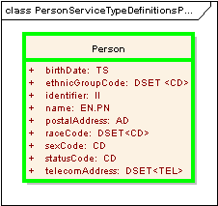

Organization Entity
The Organization entity is defined in COPPA as follows:

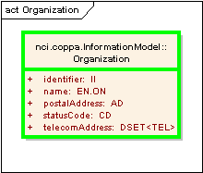

Study Protocol
The StudyProtocol entity is defined in COPPA as follows:

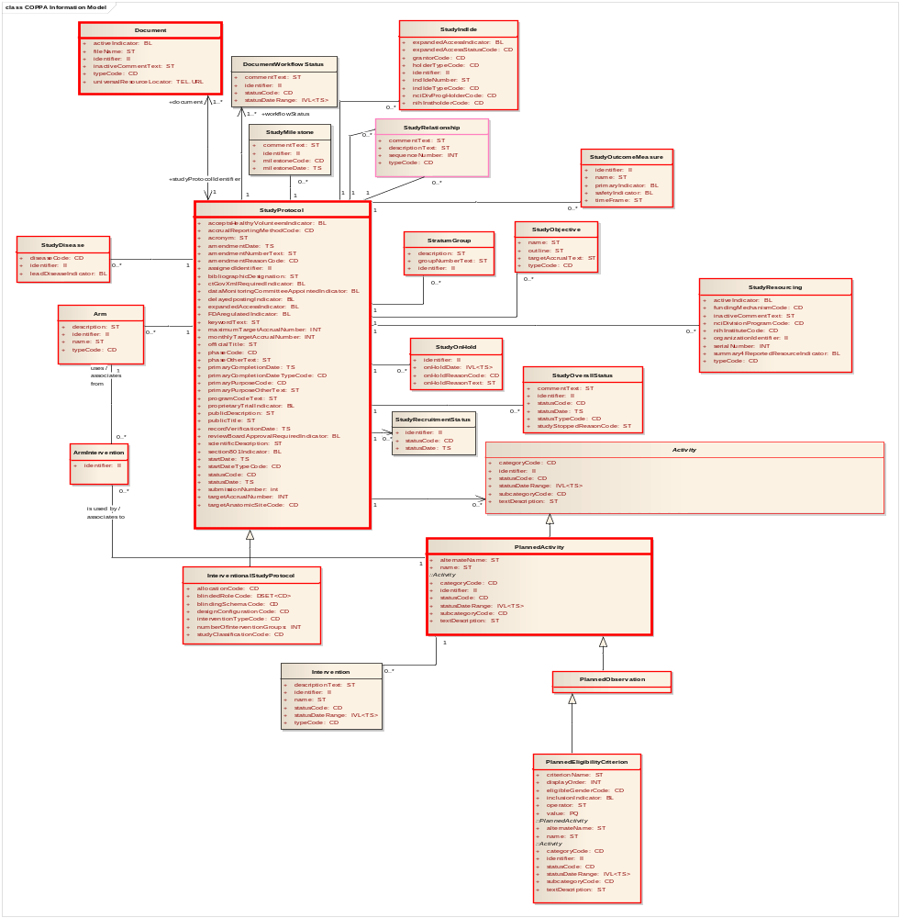

Object-Level Mapping
The following table establishes a mapping between caTissue domain objects, COPPA objects, and COPPA services used to retrieve those objects.

caTissue Object | COPPA Object | COPPA Service
User | Person | Person.wsdl
CancerResearchGroup | Organization | Organization.wsdl
Institution | Organization | Organization.wsdl
Department | Organization | Organization.wsdl
Site | Organization | Organization.wsdl
CollectionProtocol | StudyProtocol | StudyProtocolService.wsdl StudyDiseaseService.wsdl  StudyRelationshipService.wsdl  StudySiteService.wsdl  StudyContactService.wsdl

Field-Level Mapping
The following tables provide field-level mapping information for caTissue objects. “N/A” indicates the absence of COPPA mapping and that no synchronization will be performed for a given field.

Key attributes are those COPPA-mapped attributes that will be used by Edit screens to locate potential matches in COPPA when a user is entering new data via caTissue UI. For example, upon creation of a new collection protocol in caTissue, only protocol’s title would be used to search in COPPA, and protocol’s start date would not be included. Key attributes are marked with bold in the tables below.

When a new COPPA entity is being brought into caTissue: for fields, which are required but have no mapping to COPPA, either the user will be required to provide missing values via an Edit screen or a reasonable default will be assigned. Please see notes below.

Institution
caTissue Institution | COPPA Organization
name | Name

Cancer Research Group
caTissue CancerResearchGroup | COPPA Organization
name | Name

Department
caTissue Department | COPPA Organization
name | Name

Site
caTissue Site | COPPA Organization | Notes
activityStatus | statusCode
address | postalAddress
coordinator | N/A | “Administrator” is the default value.
emailAddress | telecomAddress
name | Name
type | N/A | “Not Specified” is the default value.

User
caTissue User | COPPA Person | Notes
activityStatus | statusCode | “Inactive” is the default for new users. New users require explicit approval by an administrator.
csmUserId | N/A | CSM user will be provisioned automatically for new users.
roleId | N/A | To be assigned by administrator.
address | postalAddress
comments | N/A | Blank by default.
department | N/A | To be assigned by administrator.
emailAddress | telecomAddress
firstName | Name
institution | N/A | To be assigned by administrator.
lastName | Name
loginName | N/A | To be assigned by administrator.
newPassword | N/A | To be assigned by administrator.
startDate | N/A | Current date is the default.
cancerResearchGroup | N/A | To be assigned by administrator.
siteCollection | N/A | To be assigned by administrator.
assignedProtocolCollection | N/A | To be assigned by administrator.

Collection Protocol
caTissue CollectionProtocol | COPPA StudyProtocol | Notes
aliquotInSameContainer | N/A | To be assigned by user.
assignedProtocolUserCollection | N/A | Initially empty, to be assigned by user.
childCollectionProtocolCollection | N/A | Dependent protocols will be transferred manually.
clinicalDiagnosisCollection | StudyDisease | Retrieved via StudyDiseaseService.wsdl
collectionProtocolEventCollection | N/A | Initially empty. Collection protocol events are different from COPPA Trial History or Milestones.
collectionProtocolRegistrationCollection | N/A | Empty. Registrations are a part of integration with C3PR.
consentsWaived | N/A | To be assigned by user.
consentTierCollection | N/A | To be assigned by user.
coordinatorCollection | N/A | Initially empty, To be assigned by user.
distributionProtocolCollection | N/A | To be assigned by user.
parentCollectionProtocol | StudyRelationship | Retrieved via StudyRelationshipService.wsdl
sequenceNumber | N/A
siteCollection | StudySite | StudySiteService.wsdl
studyCalendarEventPoint | N/A | To be assigned by user.
Type | N/A | Empty.
unsignedConsentDocumentURL | N/A | To be assigned by user.
activityStatus | statusCode
aliquotLabelFormat | N/A | To be assigned by user.
derivativeLabelFormat | N/A | To be assigned by user.
descriptionURL | N/A | To be assigned by user.
endDate | primaryCompletionDate
Enrollment | targetAccrualNumber
irbIdentifier | N/A | To be assigned by user.
principalInvestigator | StudyContact | StudyContactService.wsdl
shortTitle | officialTitle
specimenLabelFormat | N/A | To be assigned by user.
startDate | startDate
title | officialTitle

References

Reference | URL
CTRP | https://wiki.nci.nih.gov/x/BAAuAQ
COPPA | https://wiki.nci.nih.gov/x/XwaG
Remote Entity Manager | http://svn.semanticbits.com/RemoteEntityManager
COPPA Information Model | http://gforge.nci.nih.gov/svnroot/coppa/trunk/code/pa-grid/schema/PAServices/CoppaPO.xsd  http://gforge.nci.nih.gov/svnroot/coppa/trunk/code/pa-grid/schema/PAServices/CoppaPA.xsd
NCI NES Services | https://wiki.nci.nih.gov/x/Q4KtAQ

Participant and Collection Protocol Registration fall into the scope of integration with C3PR.
See requirement caTissue-v20-ctrp-13 in CTRP_requirements.docx.

